# [**‘Law & Order: SVU’ Begins Filming As Dick Wolf’s ‘FBI’ & ‘Chicago’ Dramas Gear Up For Production Restart**](https://deadline.com/2020/09/law-order-start-production-new-york-dick-wolf-chicago-fire-chicago-pd-chicago-med-fbi-fbi-most-wanted-1234576263/)



By [Nellie Andreeva](https://deadline.com/author/nellie/)

### [**Nellie Andreeva**](https://deadline.com/author/nellie/)

*Co-Editor-in-Chief, TV*

[@DeadlineNellie](https://twitter.com/DeadlineNellie)

[**VIEW ALL**](https://deadline.com/author/nellie/)

September 14, 2020 10:31am

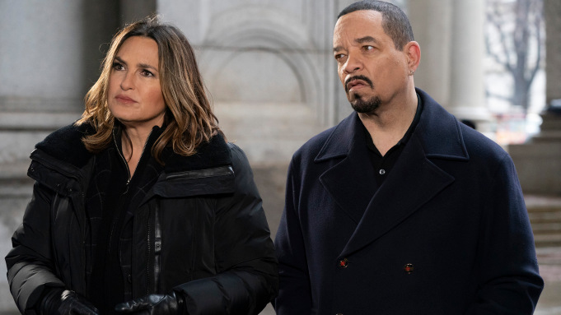

**'Law & Order': SVU'**Virginia Sherwood/NBC

TV’s longest-running primetime live-action series*,* [*Law & Order: SVU*](https://deadline.com/tag/law-order-svu/)*,* today started production on its 22nd season in New York. Star/EP Mariska Hargitay posted two behind-the-scene photos on Instagram to commemorate the occasion.

On Saturday, Hargitay shared images from the cast’s virtual table read for the season opener, which is tackling the coronavirus pandemic. Visible in one of the shots is the cover page for the Season 22 premiere script, written by *Law & Order: SVU* executive producer Julie Martin and exec producer/showrunner Warren Leight, titled “Remember Me In Quarantine” The upcoming season of *SVU* also is expected to address police brutality in the wake of George Floyd’s death and the nationwide protests it ignited.

#### RELATED STORY

### [**'Chicago Med': Tehmina Sunny To Recur On NBC Drama Series**](https://deadline.com/2020/09/chicago-med-tehmina-sunny-recur-nbc-drama-series-1234582356/)

*Law & Order: SVU* is one of four [Dick Wolf](https://deadline.com/tag/dick-wolf/) series at NBC that are heading into the first year of a three-season renewal, along with One Chicago. I hear of the three *Chicago* dramas, [*Chicago Med*](https://deadline.com/tag/chicago-med/) is currently slated to begin filming its sixth season Sept. 22, with [*Chicago Fire*](https://deadline.com/tag/chicago-fire/)and *Chicago P.D.* on track for a Oct. 6 production start. All three dramas are based in Chicago.

Wolf Entertainment’s CBS drama[*FBI*](https://deadline.com/tag/fbi/) and spinoff [*FBI: Most Wanted*](https://deadline.com/tag/fbi-most-wanted/) are expected to begin production on Season 3 and Season 2, respectively, on Oct. 6 in New York. There is no projected start date yet for the newest Dick Wolf drama series, *Law & Order: Organized Crime*, starring Chris Meloni.

All dates are tentative and subject to change as pandemic conditions remain fluid. NBCUniversal developed a comprehensive Return to Work playbook, which is being followed by all of the company’s series. It involves reducing shift hours and adding days to shoots to accommodate strict COVID protocols. All Dick Wolf shows are produced by Wolf Entertainment and Universal Television, part of Universal Studio Group. The studio has been shooting *Saved By the Bell* for Peacock and filmed comedy pilot *Night School* for NBC.

Both *FBI* and *FBI: Most Wanted* are on CBS’ fall schedule but don’t have assigned premiere dates yet. On NBC, the three *Chicago* dramas are slated to open their new seasons Nov. 11, with *Law & Order: SVU’*s 22nd season scheduled to debut the next day, Nov. 12.

Wolf’s broadcast procedurals are heading into production on the heels of the 30th anniversary of the cornerstone of his empire, the series that started it all, *Law & Order.* The venerable drama premiere on Sept. 13, 1990 and ran for 20 seasons. Wolf Entertainment marked the big anniversary on Twitter yesterday with a throwback photo.

https://www.instagram.com/p/CFHaQi-HoCV/?utm_source=ig_embed

https://www.instagram.com/p/CFBZ1ciHY2c/?utm_source=ig_embed

https://twitter.com/WolfEnt/status/1305188879788634119/photo/1?ref_src=twsrc%5Etfw%7Ctwcamp%5Etweetembed%7Ctwterm%5E1305188879788634119%7Ctwgr%5Eshare_3&ref_url=https%3A%2F%2Fdeadline.com%2F2020%2F09%2Flaw-order-start-production-new-york-dick-wolf-chicago-fire-chicago-pd-chicago-med-fbi-fbi-most-wanted-1234576263%2F